Application setup for Development instance

TABLE OF CONTENTS

Tools Required 3
JDK 1.6 3
MyEclipse6.0 4
Update Hibernate setup in Eclipse: 5
PostgreSQL 6
Tomcat 6.0 6
Configure Tomcat 6.0 with Eclipse 7
Deploying Project on Tomcat 6.0 with Eclipse 10
Subclipse 12
Create G4GOrigin 12

Tools Required

- JDK 1.6
- MyEclipse 6.0
- PostgreSQL
- Tomcat 6.0
- Subclipse
- Create G4GOrigin

JDK 1.6
- Download JDK 1.6 from …
- http://www.java.net/download/jdk6/6u10/promoted/b24/binaries/jdk-6u10-beta-bin-b24-windows-i586-p-14_may_2008.exe
- Double click on jdk-6u10-beta-bin-b24-windows-i586-p-14_may_2008.exe
- JDK will be installed and jdk1.6 will be created into C:\Program Files\java or C:\ folder
- Right Click on My Computer->Properties-> Advanced->Environment Variables ->User Variables -> New
- Set JAVA_HOME with value C:\Program Files\java\ jdk-1_6 or c:\ jdk- 1_6
- Create a CLASSPATH environment variable or update existing with value %JAVA_HOME%\lib\tools.jar;
- 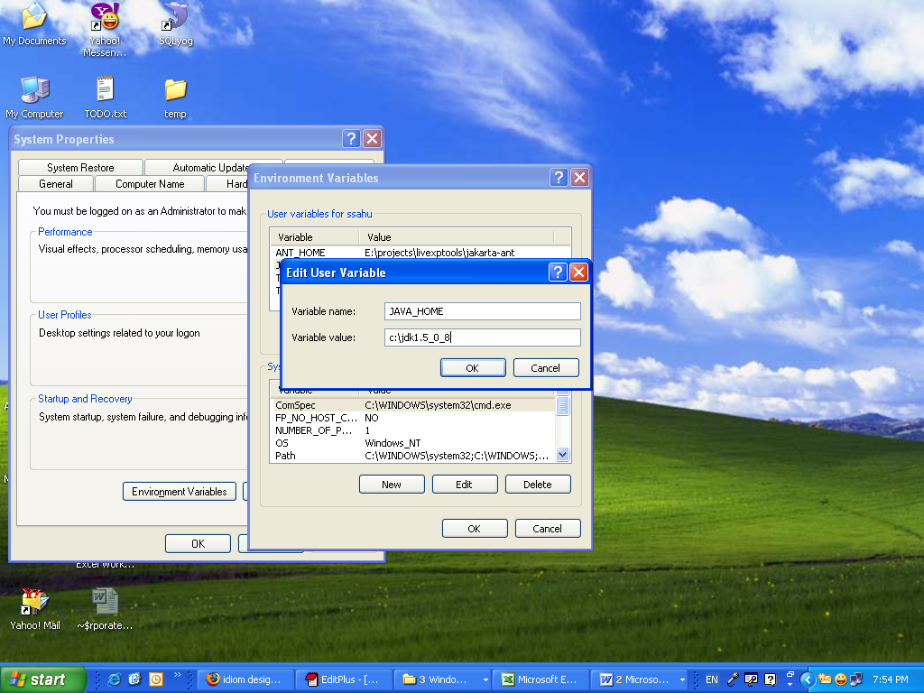

- Create PATH environment variable with value %PATH%;%JAVA_HOME%\bin.
Create PATH in Users Variable DO NOT update System Variable otherwise your windows will corrupt

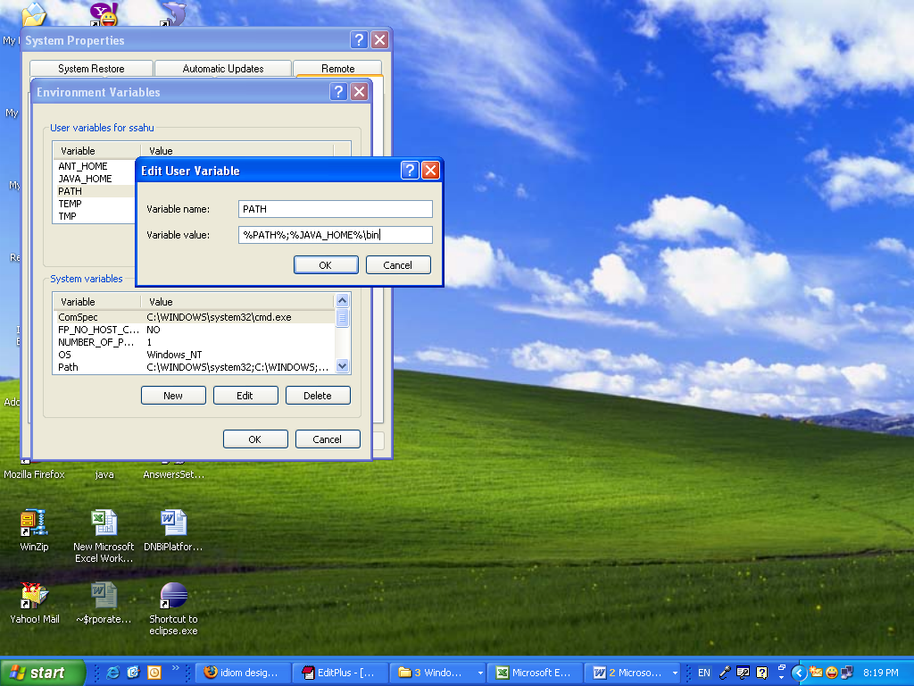

MyEclipse6.0

- Download MyEclipse http://www.myeclipseide.com/Downloads-index-req-getit-lid-95.html
- Double click on Setup and follow the instruction
- It will create directory c:\eclipse and a shortcut on desktop.
- If you didn’t find shortcut go to c:\eclipse folder
- Double click on eclipse.exe and select SendTo->Desktop to create shortcut on desktop.

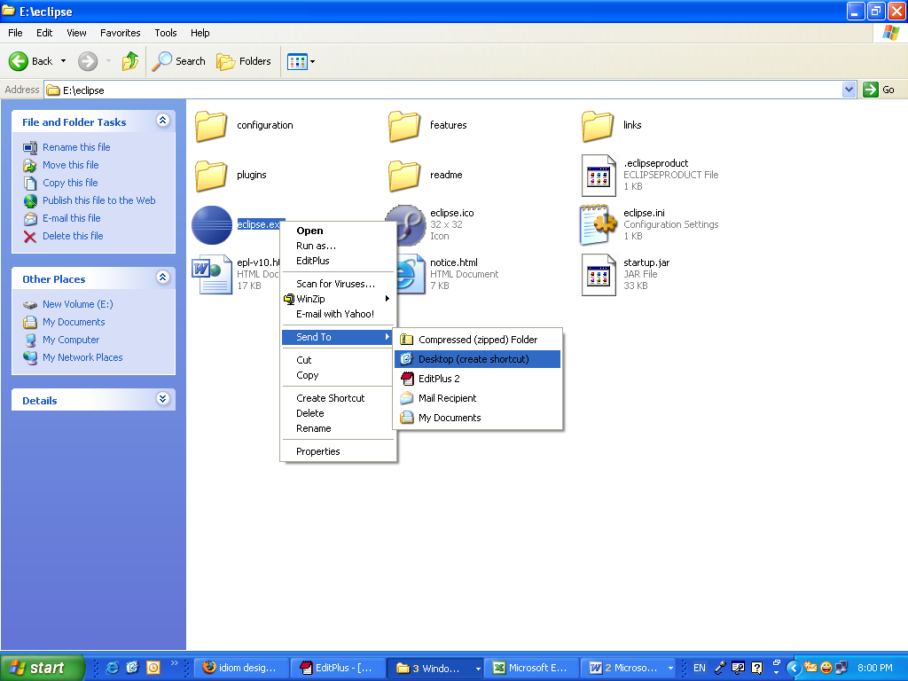

Update Hibernate setup in Eclipse:
- Window->Preferences->MyEclipse->Project capabilities
- Hibernate3.1
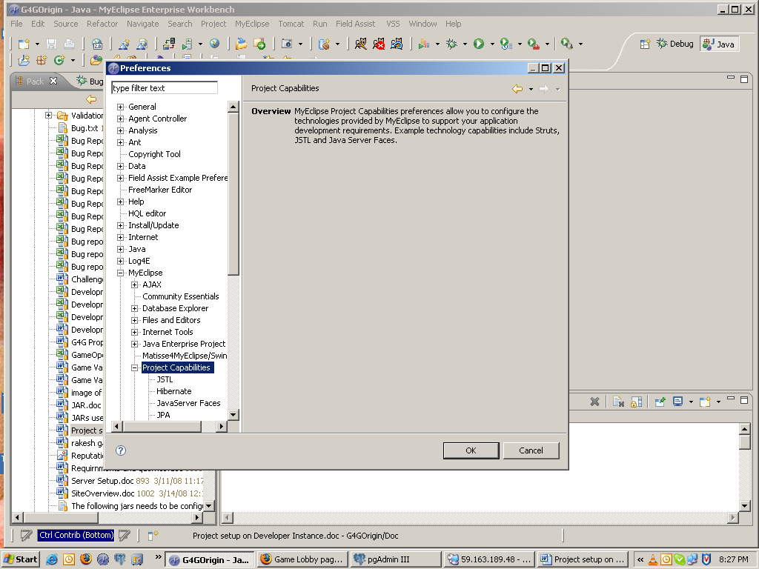
- Library modules - > Hibernate3.1 Core Libraries remove “commons-collections-2.1.1.jar”
- Add new jar “commons-collections-3.1.jar”
- Manually remove “commons-collections-2.1.1.jar” from "C:\Tools\MyEclipse 6.0\myeclipse\eclipse\plugins\com.genuitec.org.hibernate.eclipse_6.0.1.zmyeclipse601200710\myeclipse-data\3.0\lib\" Or where you had created your MyEclipse folder

PostgreSQL
- ftp://ftp10.us.postgresql.org/pub/postgresql//binary/v8.3.0/win32/postgresql-8.3.0-1.zip
- Its installation steps are on site http://pginstaller.projects.postgresql.org/
- On step 5 leave the domain as it is and choose the password carefully and note down all the information
- On step 6 choose the password as root
- Open PGAdminIII from program files Create a new database G4GOrigin
- Run SQL Files as provided in G4GOrigin SQL folder

Tomcat 6.0
- Download Tomcat 6.0 from :
http://ftp.wayne.edu/apache/tomcat/tomcat-6/v6.0.16/bin/apache-tomcat-6.0.16.tar.gz
- Extract it in c:/tools/apache-tomcat-6.0.16 Or in any folder note down it’s path
- Create an CATALINA_HOME environment variable with value C:\Tools\apache-tomcat-6.0.16
- Update PATH user variable set value %PATH%;%JAVA_HOME%\bin;%CATALINA_HOME%/bin
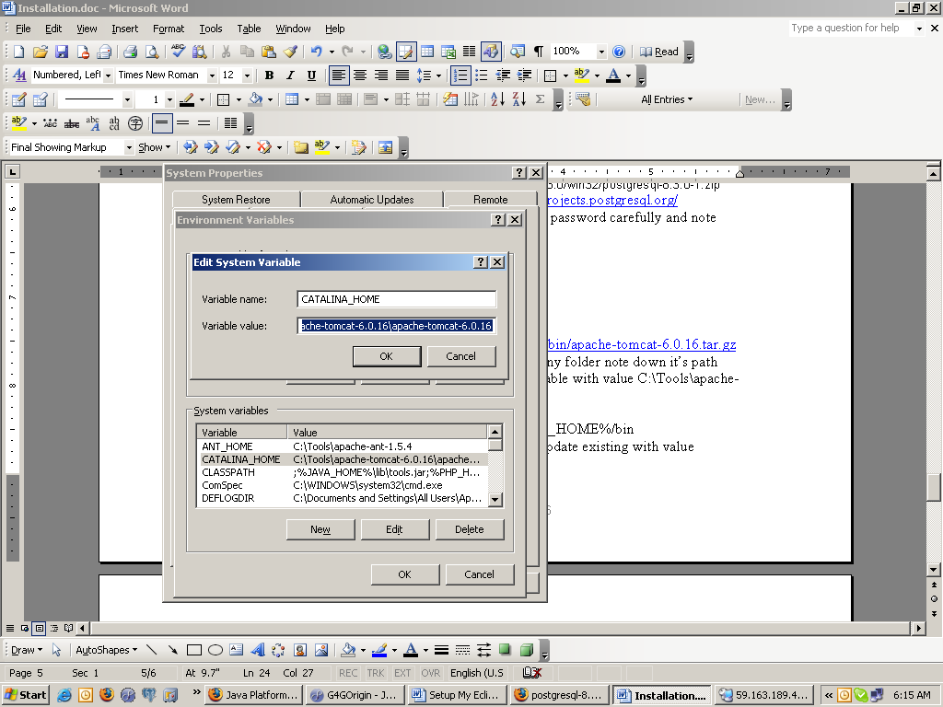

Configure Tomcat 6.0 with Eclipse
- To configure a connector for you favorite application server, open the Application Server Connector preferences dialog using the button on the Server Manager toolbar or from the main Eclipse menubar by choosing Window > Preferences > MyEclipse.>Servers>Tomcat6.x
- Enable the connector
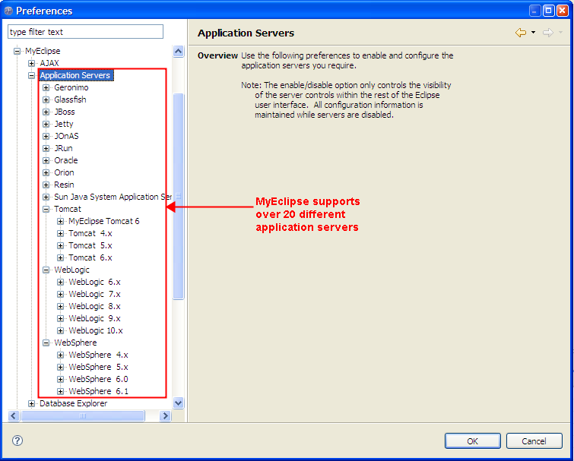
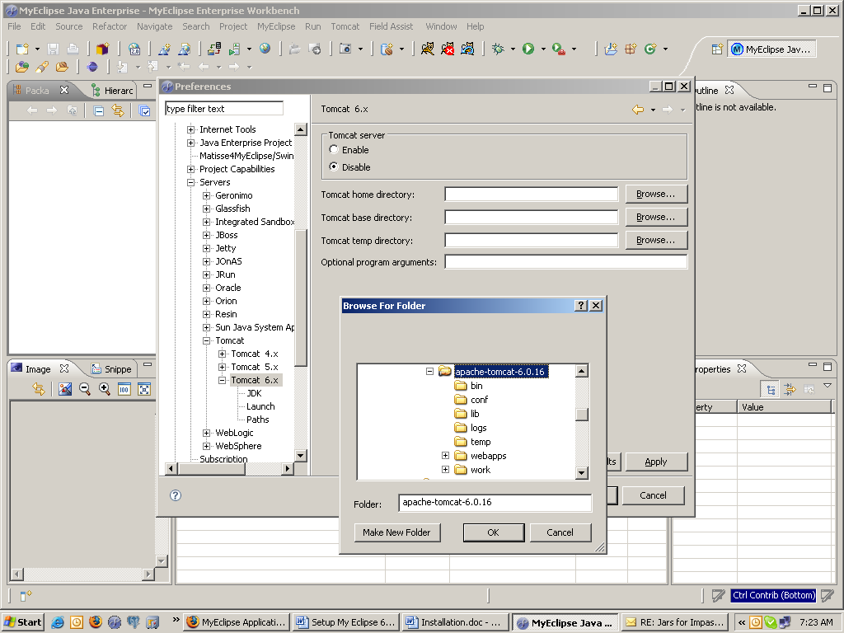

- Browse and select tomcat root dir.
- Under JDK
Set the JAVA OPTIONS through Eclipse by putting all the given options as follows.(Adjust this as per your configuration)
-Djava.awt.headless=false
-Djava.endorsed.dirs="c:\Tools\Java\jdk1.6.0_02\jre\lib\endorsed"
-DLOG_DIR="C:\Tools\workspace-G4GOrigin\G4GOrigin\logs"
-DWORK_DIR="C:\Tools\workspace-G4GOrigin\G4GOrigin"
-DDOC_DIR="C:\Tools\workspace-G4GOrigin\G4GOrigin"
-DAPP_DOC_DIR="C:\Tools\workspace-G4GOrigin\G4GOrigin\WebRoot\WEB-INF"
-DSERVER_INSTANCE=SANDBOX
- Click on Add
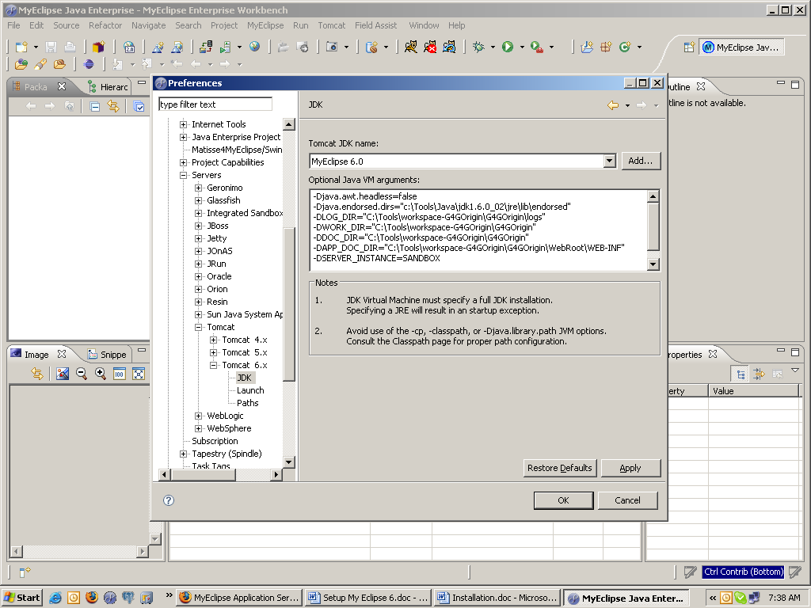
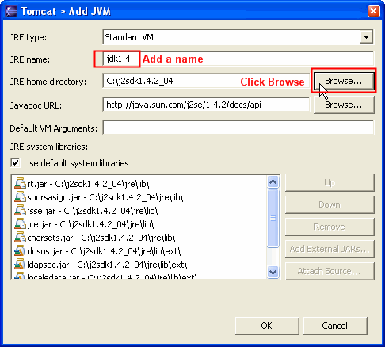

- Choose jdk1.6 directory “C:\Program Files\java\jdk1.6”
- After finishing click on OK.

Deploying Project on Tomcat 6.0 with Eclipse
- To deploy a J2EE project select the button found on the toolbar of the Server Manager or the MyEclipse perspective workbench. This will launch the Project Deployments dialog,
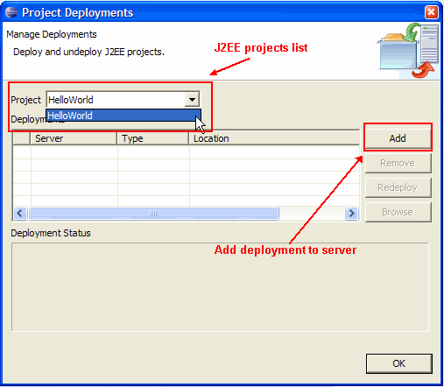
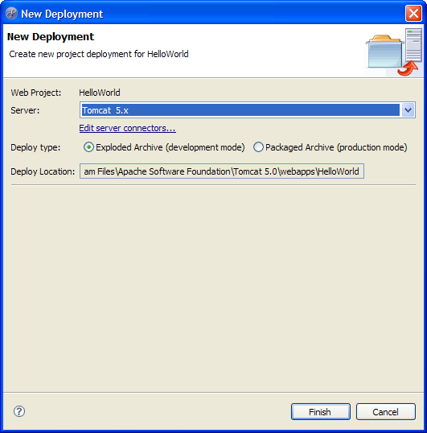

- For further assistance refer http://www.myeclipseide.com/documentation/quickstarts/appservers/\

Subclipse
- Open MyEclipse
- Read and follow instruction on http://subclipse.tigris.org/install.html

Create printeverywhere

